JENKINS CHALLENGERS -01
Use the below code and implement our CICD stages.
Source Code: https://github.com/karthikhastag/hiring-app.git
Repository contains the application code for the hiring app.
Create one Declarative pipeline job
Create one Scripted pipeline job
Create one multi stage pipeline job
Create one parallel stage pipeline job
Jenkins Official Documentation:
Pipeline: https://www.jenkins.io/doc/book/pipeline/
Environment Variables: https://www.jenkins.io/doc/book/pipeline/jenkinsfile/#using-environment-variables
Parameters: https://www.jenkins.io/doc/book/pipeline/syntax/#parameters
Handling credentials in Pipeline: https://www.jenkins.io/doc/book/pipeline/jenkinsfile/#handling-credentials
Code
pipeline {
agent any

tools {
maven 'MVN_HOME'
}

environment {
SONAR_PROJECT_KEY = 'Sabear'
SONAR_PROJECT_NAME = 'Sabear'

SONARQUBE_URL = 'http://98.82.22.220:9000'

NEXUS_URL = '52.90.65.71:8081'
NEXUS_REPO = 'hiring_Maven_Webapp'
NEXUS_CRED = 'nexus-token'

TOMCAT_URL = 'http://52.207.232.106:9090'
TOMCAT_CONTEXT = 'simplecustomerapp'
TOMCAT_CRED = 'tomcat-deployer'

SLACK_CHANNEL = '#jenkins-integration'
}

stages {

stage('Notify Build Started') {
steps {
slackSend(
channel: "${SLACK_CHANNEL}",
color: '#439FE0',
message: "*BUILD STARTED*\nJob: ${env.JOB_NAME}\nBuild: #${env.BUILD_NUMBER}\n${env.BUILD_URL}"
)
}
}

stage('Git Clone') {
steps {
git branch: 'main',
url: 'https://github.com/betawins/hiring-app.git'
}
}

stage('Maven Build') {
steps {
sh 'mvn clean package -DskipTests'
}
}

stage('SonarQube Analysis') {
options {
timeout(time: 10, unit: 'MINUTES')
}
steps {
withSonarQubeEnv('SonarQube') {
sh '''
mvn org.sonarsource.scanner.maven:sonar-maven-plugin:5.5.0.6356:sonar \
-Dsonar.projectKey=Sabear \
-Dsonar.projectName=Sabear
'''
}
}
}

stage('Upload WAR to Nexus') {
steps {
withCredentials([usernamePassword(
credentialsId: "${NEXUS_CRED}",
usernameVariable: 'NEXUS_USER',
passwordVariable: 'NEXUS_PASS'
)]) {
sh '''
WAR_FILE=$(ls target/*.war | head -n 1)

curl -u $NEXUS_USER:$NEXUS_PASS \
--upload-file $WAR_FILE \
http://${NEXUS_URL}/repository/${NEXUS_REPO}/com/javahome/hiring/${BUILD_NUMBER}/hiring-${BUILD_NUMBER}.war
'''
}
}
}

stage('Deploy to Tomcat') {
steps {
withCredentials([usernamePassword(
credentialsId: "${TOMCAT_CRED}",
usernameVariable: 'TOMCAT_USER',
passwordVariable: 'TOMCAT_PASS'
)]) {
sh '''
WAR_FILE=$(ls target/*.war | head -n 1)

curl -u $TOMCAT_USER:$TOMCAT_PASS \
-T $WAR_FILE \
"${TOMCAT_URL}/manager/text/deploy?path=/${TOMCAT_CONTEXT}&update=true"
'''
}
}
}
}

post {
success {
slackSend(
channel: "${SLACK_CHANNEL}",
color: 'good',
message: "*BUILD SUCCESS*\nJob: ${env.JOB_NAME}\nBuild: #${env.BUILD_NUMBER}\n${env.BUILD_URL}"
)
}

failure {
slackSend(
channel: "${SLACK_CHANNEL}",
color: 'danger',
message: "*BUILD FAILED*\nJob: ${env.JOB_NAME}\nBuild: #${env.BUILD_NUMBER}\n${env.BUILD_URL}"
)
}
}
}
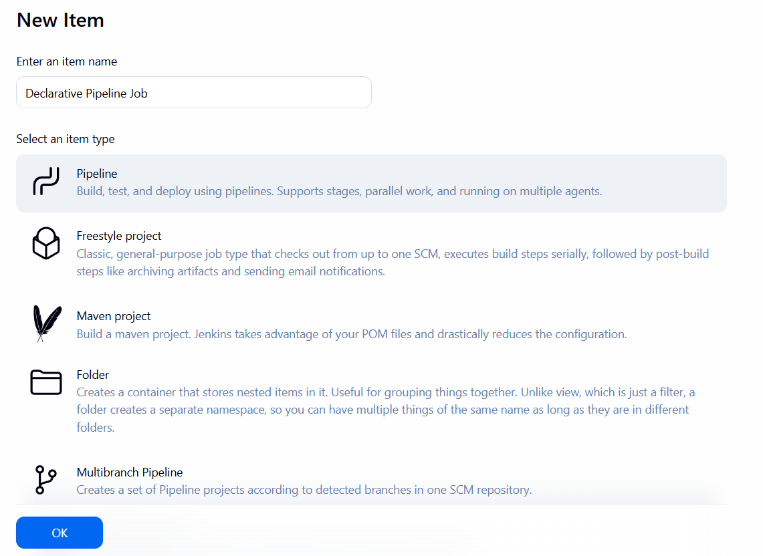
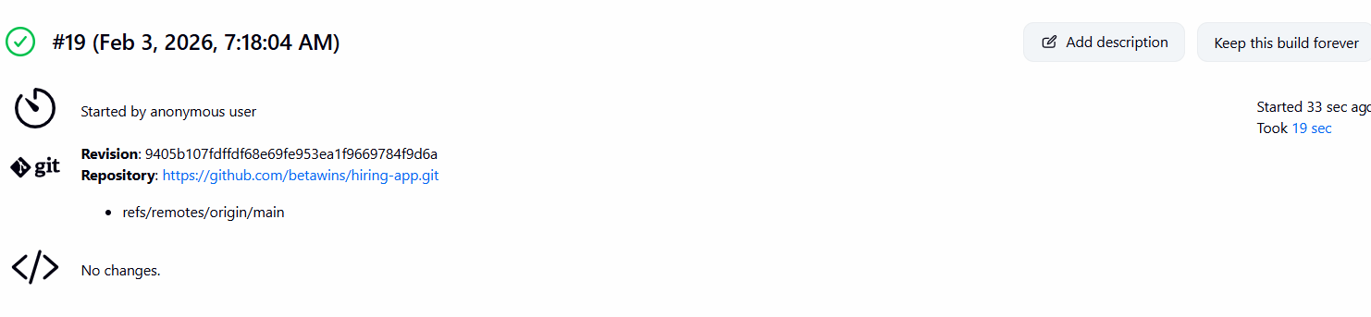
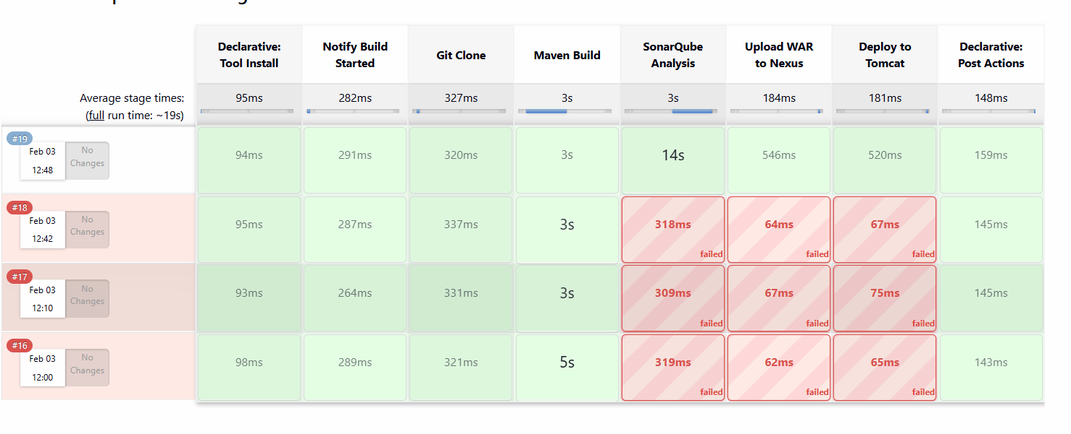
Create one Scripted pipeline job
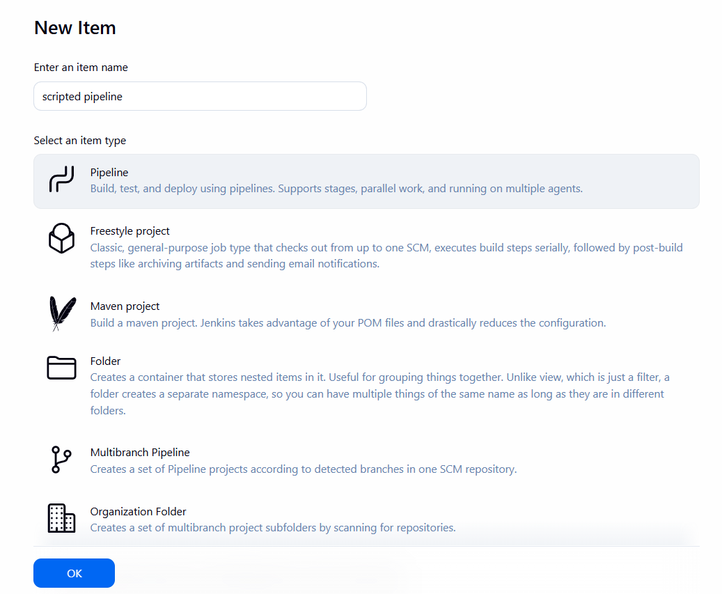
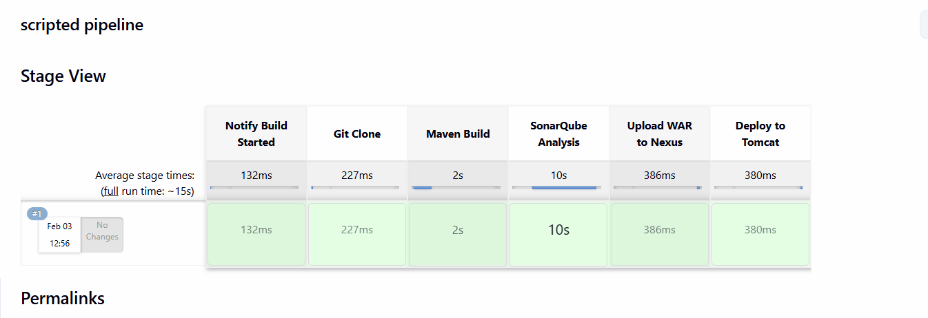
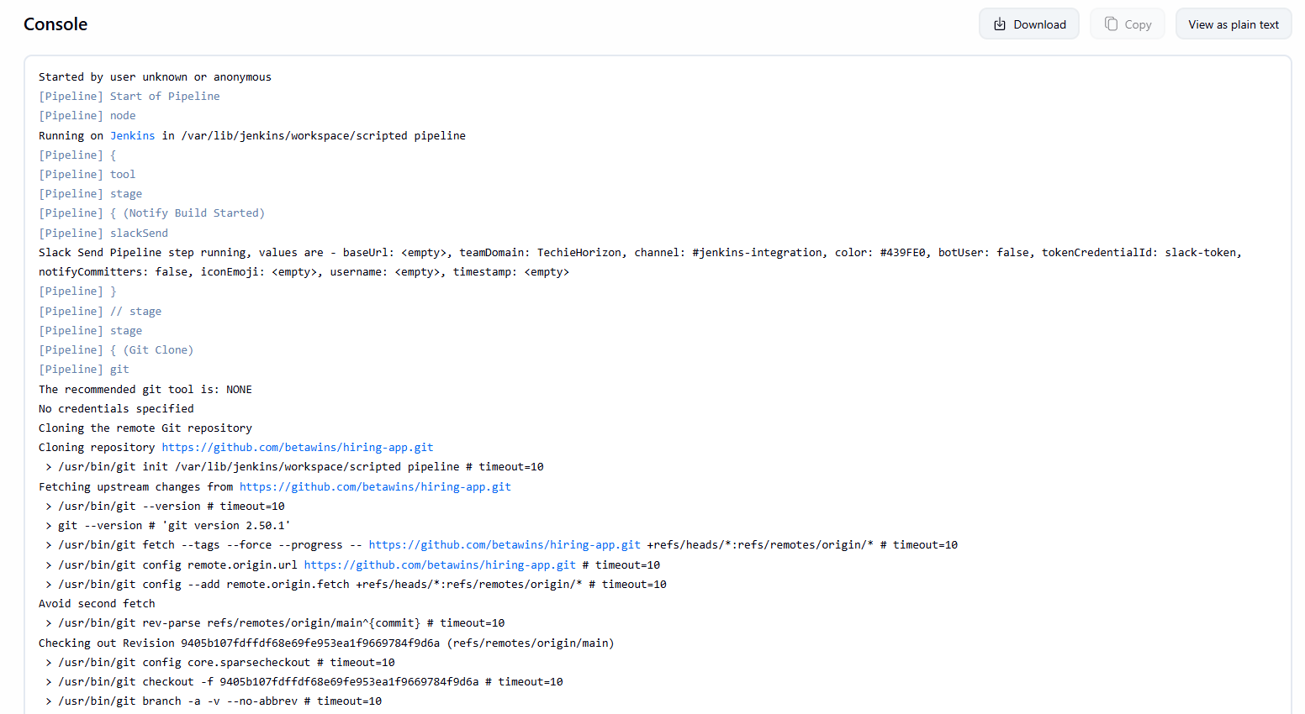
Code:-
node {

/* ================= TOOLS ================= */
def mvnHome = tool name: 'MVN_HOME', type: 'maven'
env.PATH = "${mvnHome}/bin:${env.PATH}"

/* ================= ENV VARIABLES ================= */
env.SONAR_PROJECT_KEY = 'Sabear'
env.SONAR_PROJECT_NAME = 'Sabear'
env.SONARQUBE_URL = 'http://98.82.22.220:9000'

env.NEXUS_URL = '52.90.65.71:8081'
env.NEXUS_REPO = 'hiring_Maven_Webapp'
env.NEXUS_CRED = 'nexus-token'

env.TOMCAT_URL = 'http://52.207.232.106:9090'
env.TOMCAT_CONTEXT = 'simplecustomerapp'
env.TOMCAT_CRED = 'tomcat-deployer'

env.SLACK_CHANNEL = '#jenkins-integration'

try {

/* ========== NOTIFY BUILD STARTED ========== */
stage('Notify Build Started') {
slackSend(
channel: env.SLACK_CHANNEL,
color: '#439FE0',
message: "*BUILD STARTED*\nJob: ${env.JOB_NAME}\nBuild: #${env.BUILD_NUMBER}\n${env.BUILD_URL}"
)
}

/* ========== GIT CLONE ========== */
stage('Git Clone') {
git branch: 'main',
url: 'https://github.com/betawins/hiring-app.git'
}

/* ========== MAVEN BUILD ========== */
stage('Maven Build') {
sh 'mvn clean package -DskipTests'
}

/* ========== SONARQUBE ANALYSIS ========== */
stage('SonarQube Analysis') {
timeout(time: 10, unit: 'MINUTES') {
withSonarQubeEnv('SonarQube') {
sh """
mvn org.sonarsource.scanner.maven:sonar-maven-plugin:5.5.0.6356:sonar \
-Dsonar.projectKey=${env.SONAR_PROJECT_KEY} \
-Dsonar.projectName=${env.SONAR_PROJECT_NAME}
"""
}
}
}

/* ========== UPLOAD WAR TO NEXUS ========== */
stage('Upload WAR to Nexus') {
withCredentials([usernamePassword(
credentialsId: env.NEXUS_CRED,
usernameVariable: 'NEXUS_USER',
passwordVariable: 'NEXUS_PASS'
)]) {
sh '''
WAR_FILE=$(ls target/*.war | head -n 1)

curl -u $NEXUS_USER:$NEXUS_PASS \
--upload-file $WAR_FILE \
http://${NEXUS_URL}/repository/${NEXUS_REPO}/com/javahome/hiring/${BUILD_NUMBER}/hiring-${BUILD_NUMBER}.war
'''
}
}

/* ========== DEPLOY TO TOMCAT ========== */
stage('Deploy to Tomcat') {
withCredentials([usernamePassword(
credentialsId: env.TOMCAT_CRED,
usernameVariable: 'TOMCAT_USER',
passwordVariable: 'TOMCAT_PASS'
)]) {
sh '''
WAR_FILE=$(ls target/*.war | head -n 1)

curl -u $TOMCAT_USER:$TOMCAT_PASS \
-T $WAR_FILE \
"${TOMCAT_URL}/manager/text/deploy?path=/${TOMCAT_CONTEXT}&update=true"
'''
}
}

/* ========== SUCCESS NOTIFICATION ========== */
slackSend(
channel: env.SLACK_CHANNEL,
color: 'good',
message: "*BUILD SUCCESS*\nJob: ${env.JOB_NAME}\nBuild: #${env.BUILD_NUMBER}\n${env.BUILD_URL}"
)

} catch (err) {

/* ========== FAILURE NOTIFICATION ========== */
slackSend(
channel: env.SLACK_CHANNEL,
color: 'danger',
message: "*BUILD FAILED*\nJob: ${env.JOB_NAME}\nBuild: #${env.BUILD_NUMBER}\n${env.BUILD_URL}"
)

throw err
}
}
3. Create one multi stage pipeline job
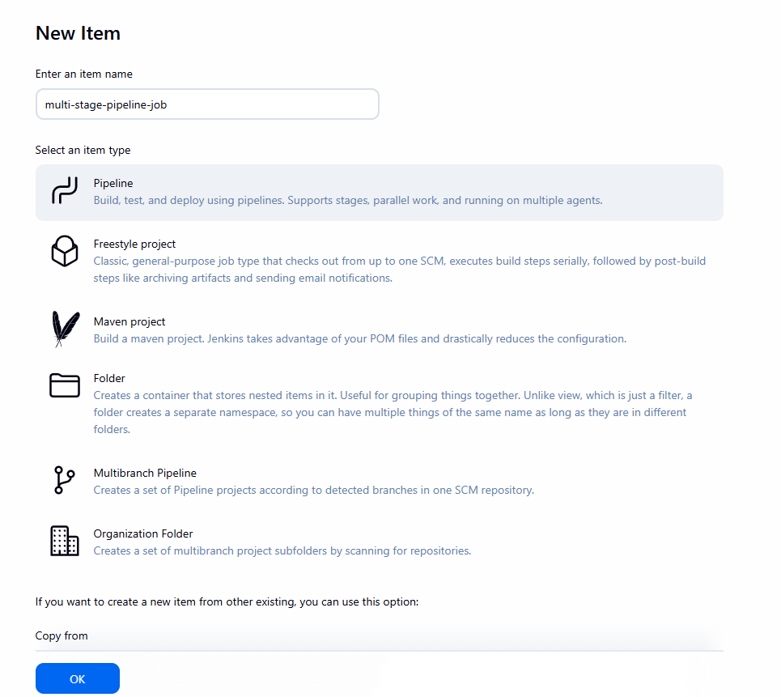
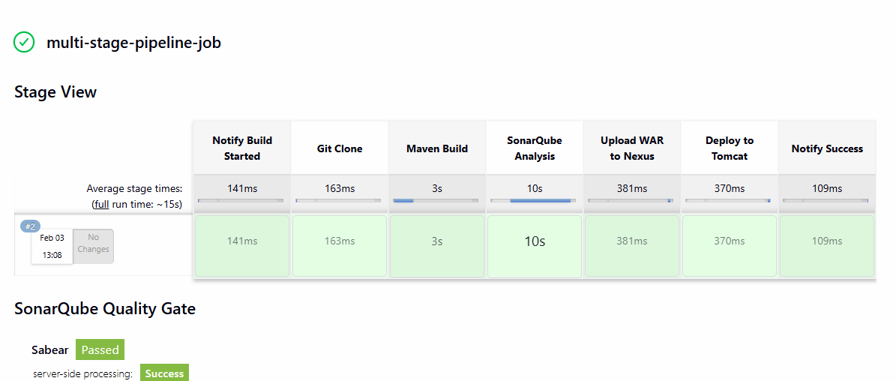
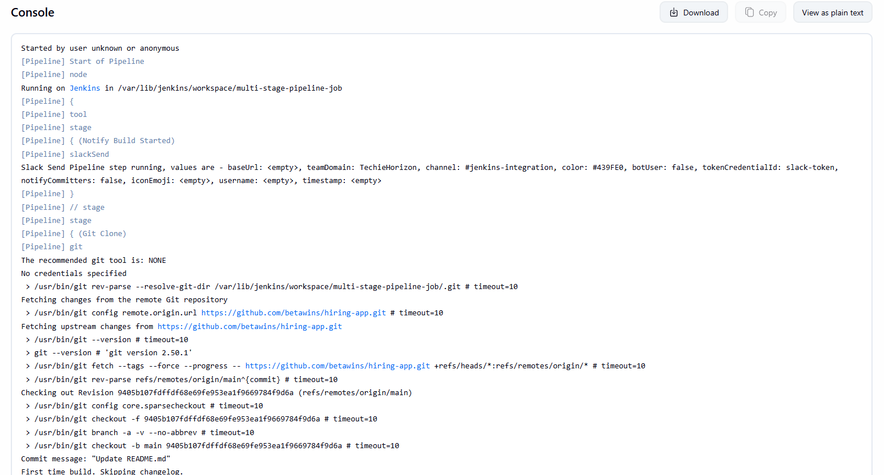
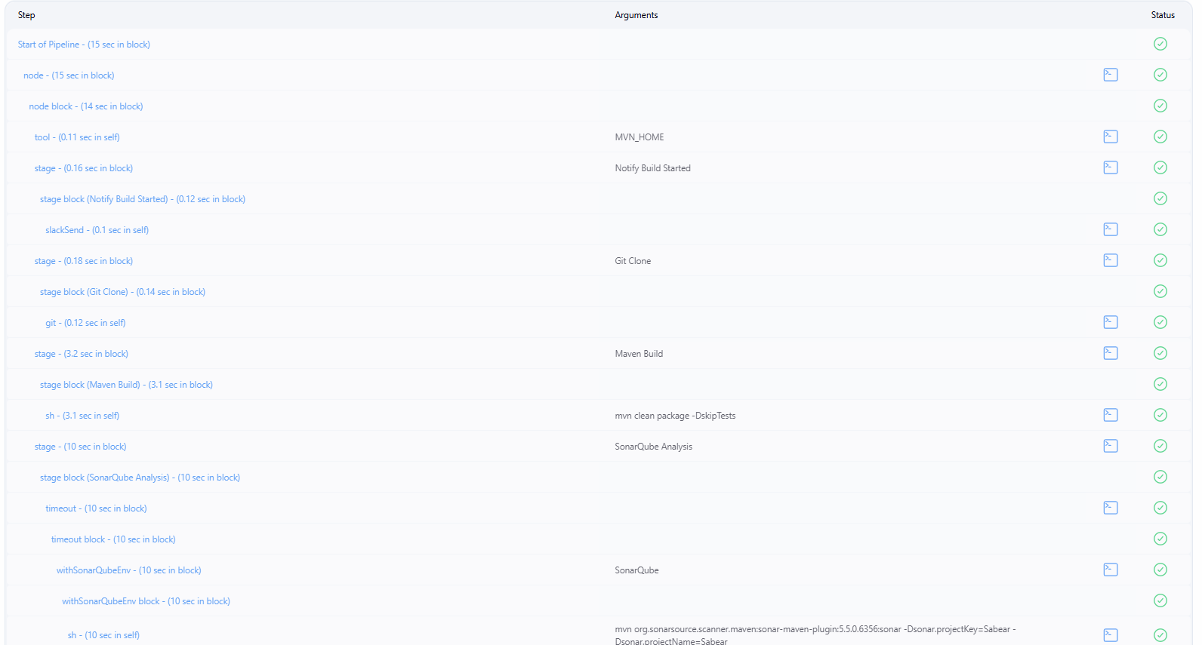
Create one parallel stage pipeline job
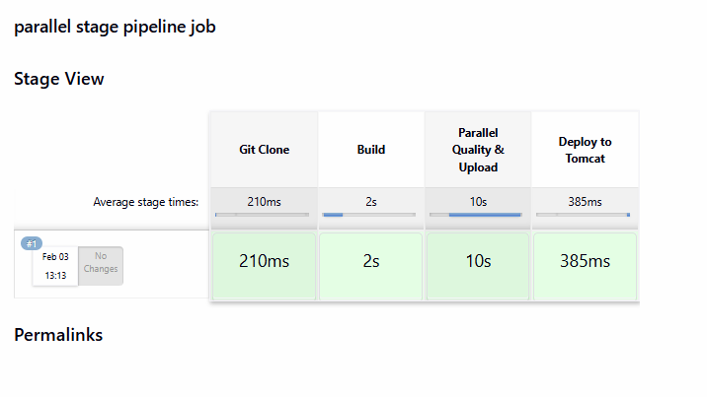
Code node {

def mvnHome = tool name: 'MVN_HOME', type: 'maven'
env.PATH = "${mvnHome}/bin:${env.PATH}"

env.SONAR_PROJECT_KEY = 'Sabear'
env.SONAR_PROJECT_NAME = 'Sabear'
env.NEXUS_CRED = 'nexus-token'
env.TOMCAT_CRED = 'tomcat-deployer'

stage('Git Clone') {
git branch: 'main',
url: 'https://github.com/betawins/hiring-app.git'
}

stage('Build') {
sh 'mvn clean package -DskipTests'
}

/* ========== PARALLEL STAGE ========== */
stage('Parallel Quality & Upload') {
parallel(

'SonarQube Analysis': {
withSonarQubeEnv('SonarQube') {
sh 'mvn sonar:sonar'
}
},

'Upload WAR to Nexus': {
withCredentials([usernamePassword(
credentialsId: env.NEXUS_CRED,
usernameVariable: 'NEXUS_USER',
passwordVariable: 'NEXUS_PASS'
)]) {
sh '''
WAR_FILE=$(ls target/*.war | head -n 1)
echo "Uploading $WAR_FILE to Nexus"
'''
}
}
)
}

stage('Deploy to Tomcat') {
withCredentials([usernamePassword(
credentialsId: env.TOMCAT_CRED,
usernameVariable: 'TOMCAT_USER',
passwordVariable: 'TOMCAT_PASS'
)]) {
sh 'echo "Deploying WAR to Tomcat"'
}
}
}